SQL Project
Blinkit Sales Analysis Report

Data Cleaning
- Fixing irregular entries in item_fat_content column.
Approach- There are certain records in the column which are evidently not aligned with the major amount of category records in “Low Fat” and “Regular”. We can clearly witness the entries like “LF”, “low fat”, “reg” etc. The approach is to bifurcate all the records in “Low Fat and “Regular” category only. I will be querying update command to fix it.

UPDATE blinkit
SET item_fat_content =
CASE
WHEN item_fat_content IN ("LF","low fat") THEN "Low Fat"
WHEN item_fat_content = "reg" THEN "Regular"
ELSE item_fat_content
END
WHERE item_fat_content IS NOT NULL
LIMIT 8523;
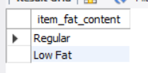

- Finding Missing values and fixing it .

SELECT
SUM(CASE WHEN item_fat_content IS NULL THEN 1 ELSE 0 END) AS null_item_fat,
SUM(CASE WHEN item_identifier IS NULL THEN 1 ELSE 0 END) AS null_item_identifier,
SUM(CASE WHEN item_type IS NULL THEN 1 ELSE 0 END) AS null_item_type,
SUM(CASE WHEN outlet_establishment_year IS NULL THEN 1 ELSE 0 END) AS null_establishment,
SUM(CASE WHEN outlet_identifier IS NULL THEN 1 ELSE 0 END) AS null_outlet_identifier,
SUM(CASE WHEN outlet_location_type IS NULL THEN 1 ELSE 0 END) AS null_location_type,
SUM(CASE WHEN outlet_size IS NULL THEN 1 ELSE 0 END) AS null_outlet_size,
SUM(CASE WHEN item_visibility IS NULL THEN 1 ELSE 0 END) AS null_item_visibility,
SUM(CASE WHEN item_weight IS NULL THEN 1 ELSE 0 END) AS null_item_weight,
SUM(CASE WHEN total_sales IS NULL THEN 1 ELSE 0 END) AS null_total_sales,
SUM(CASE WHEN Rating IS NULL THEN 1 ELSE 0 END) AS null_ratings
FROM
blinkit; -- null_item_weight - 1463 records
- Total 1463 records were fetched as null values in item_weight feature.
- The further approach was to find out average and median item_weight and I found out that average item_weight was 12.86 and median weight 11.
- Imputed all the missing records with the median value 11.

KPI Requirements
- Total Sales of blinkit in millions.
SELECT
CONCAT_WS(" ",CAST(SUM(total_sales)/1000000 AS DECIMAL(10,2)),"M") AS total_net_sales
FROM
blinkit;
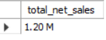

- Average Sales.
SELECT
CAST(AVG(total_sales) AS DECIMAL(10,2)) AS average_sales
FROM
blinkit;
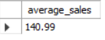

- Total orders (Number of Items)
SELECT
COUNT(item_type) AS total_orders
FROM
blinkit;
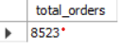
- Average ratings across all stores.
SELECT
CAST(AVG(Rating) AS DECIMAL(10,2)) AS avg_rating
FROM
blinkit;
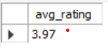

Granular Requirements

- Performance analysis by fat content.

SELECT
item_fat_content,
CAST(SUM(total_sales) AS DECIMAL(10,2)) AS total_sales,
CAST(AVG(total_sales) AS DECIMAL(10,2)) AS avg_sales,
COUNT(*) AS total_orders,
CAST(AVG(Rating) AS DECIMAL(10,2)) AS avg_rating
FROM
blinkit
GROUP BY
item_fat_content
ORDER BY
total_sales DESC;

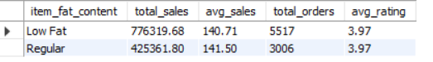

- Performance analysis by item type.

SELECT
item_type,
CAST(SUM(total_sales) AS DECIMAL(10,2)) AS total_sales,
CAST(AVG(total_sales) AS DECIMAL(10,2)) AS avg_sales,
COUNT(*) AS total_orders,
CAST(AVG(Rating) AS DECIMAL(10,2)) AS avg_rating
FROM
blinkit
GROUP BY
item_type
ORDER BY
total_sales DESC;

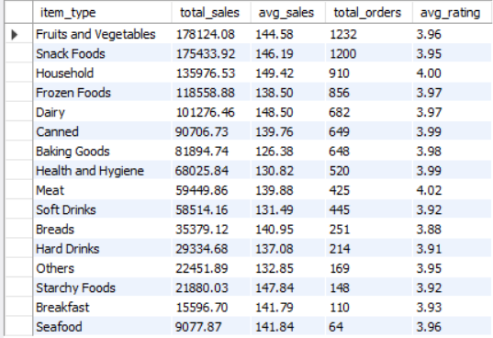

- Performance analysis by fat content and outlet location type.

SELECT
outlet_location_type,
item_fat_content,
CAST(SUM(total_sales) AS DECIMAL(10,2)) AS total_sales
FROM
blinkit
GROUP BY
outlet_location_type,item_fat_content
ORDER BY
total_sales DESC;

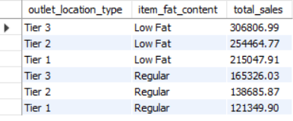

- Total sales by outlet establishment.
SELECT
outlet_establishment_year,
CAST(SUM(total_sales) AS DECIMAL(10,2)) AS total_sales
FROM
blinkit
GROUP BY
outlet_establishment_year
ORDER BY
outlet_establishment_year ASC;

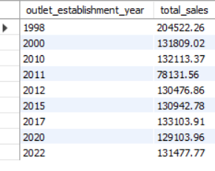

- Percentage of sales by outlet size.

WITH blinkit_total_sales AS (
SELECT
ROUND(SUM(total_sales),2) AS total_sales_net
FROM
blinkit ) , outlet_total_sales AS (
SELECT
outlet_size ,ROUND(SUM(total_sales),2) AS outlet_sales , total_sales_net
FROM
blinkit
JOIN blinkit_total_sales
GROUP BY outlet_size,total_sales_net)
SELECT *,ROUND((outlet_sales/total_sales_net)*100,2) AS "%_sales" FROM outlet_total_sales;
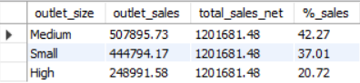

- Performance metrics for outlet location type.

SELECT
outlet_location_type,
CAST(SUM(total_sales) AS DECIMAL(10,2)) AS location_sales,
COUNT(*) AS location_wise_total_orders,
CAST(AVG(Rating) AS DECIMAL(10,2)) AS location_avg_rating
FROM
blinkit
GROUP BY
outlet_location_type
ORDER BY
location_sales DESC,
location_wise_total_orders DESC,
location_avg_rating DESC;

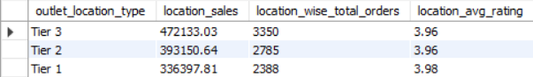

- All metrics by outlet type.

SELECT
outlet_type,
CAST(SUM(total_sales) AS DECIMAL(10,2)) AS total_sales,
CAST(AVG(total_sales) AS DECIMAL(10,2)) AS avg_sales,
COUNT(*) AS total_orders,
CAST(AVG(Rating) AS DECIMAL(10,2)) AS avg_rating
FROM
blinkit
GROUP BY
outlet_type
ORDER BY
total_sales DESC,
avg_sales DESC,
total_orders DESC,
avg_rating DESC;
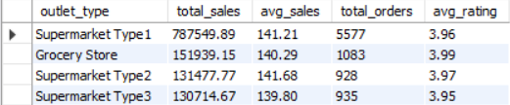

Findings
- Average rating of 3.97 for overall stores indicates a positive signal of customer preference towards blinkit stores.
- In terms of total sales, Low fat items have completely outperformed regular items by around 45 % as compared to the overall sales from blinkit stores.
- Tier -3 and Tier -2 locations have turned out to be more attractive market in terms total sales as compared to Tier-1 in both low fat and regular category items.
- Fruit and vegetables, Snack items and household items are the clear winners in the category contributing to 40.73 % of the total revenue generated from the overall blinkit stores.
- Medium and small sized stores have outperformed as compared to the high sized stores which have contributed 79,28 % revenue as comparted to the total overall revenue generated from all blinkit stores.

Recommendations
- It is recommended to consider the market expansions in Tier 3 and Tier 2 i.e. semi urban regions with the growing awareness and demand amongst the customers for blinkit brand.
- It is recommended to invest in medium and small sized stores set up and save the infrastructure costs which are higher towards high sized outlets.
- Increase the shelf space and availability in the outlets for low performing categories such as starchy foods, breakfast items and seafood but with complete scrutiny as it should not affect the shelf spaces of the high performing categories such as fruit and vegetables, household and snack items.
- With time passing by, customers have always evolved and changed their lifestyle habits and preferences and it can be evidently witnessed with the sales figure of Low fat and Regular item categories which clearly indicates that the customers are inclined towards healthy and nutritious lifestyle habits. It is recommended to increase the product segmentation towards fat free items to capitalize the current market trends.

